 | 12.1.56 Editors - Geometry Nodes Editor - Header - Add Menu - Geometry Nodegroups - Hair - Guides
Table of content
Detailed table of content 1
Add menu - Hair - Guides 3
Braid Hair Curves 4
Clump Hair Curves 6
Create Guide Index Map 7
Curl Hair Curves 8

Detailed table of content
Detailed table of content
Detailed table of content 1
Add menu - Hair - Guides 3
Braid Hair Curves 4
Input 4
Geometry 4
Guide Index 4
Guide Distance 4
Guide Mask 4
Existing Guide Map 4
Factor 4
Subdivision 4
Braid Start 4
Radius 4
Shape 4
Factor Min 4
Factor Max 4
Frequency 5
Thickness 5
Thickness Shape 5
Shape Assymetry 5
Flare Length 5
Flare Opening 5
Hair Tie Object 5
Hair Tie 5
Hair Tie Scale 5
Output 5
Geometry 5
Guide Index 5
Flare Parameter 5
Strand Index 5
Clump Hair Curves 6
Input 6
Geometry 6
Guide Index 6
Guide Distance 6
Guide Mask 6
Existing Guide Map 6
Factor 6
Shape 6
Tip Spread 6
Clump Offset 6
Distance Falloff 6
Distance Threshold 6
Preserve Length 6
Output 7
Geometry 7
Guide Index 7
Create Guide Index Map 7
Input 7
Geometry 7
Guides 7
Guide Distance 7
Guide Mask 7
Group ID 7
Output 7
Geometry 7
Guide Curves 7
Guide Index 7
Guide Selection 7
Curl Hair Curves 8
Input 8
Geometry 8
Guide Index 8
Guide Distance 8
Guide Mask 8
Existing Guide Map 8
Factor 8
Subdivision 8
Curl start 8
Radius 8
Factor Start 8
Factor End 8
Frequency 8
Random Offset 8
Seed 9
Output 9
Geometry 9

Add menu - Hair - Guides

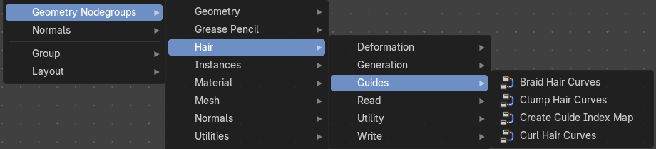
The nodes in this submenu are node groups. They use the regular single nodes under the hood.
It is virtually impossible to document these nodes in detail. So we will just list them.
When you double click the header, then you will enter the first level of the group. When you then press tab, or click again at the header, then you will reach the single nodes.




To leave the group you can use the breadcrumb up left in the header. These breadcrumbs are clickable. Or the Parent Node Tree button up right in the header.

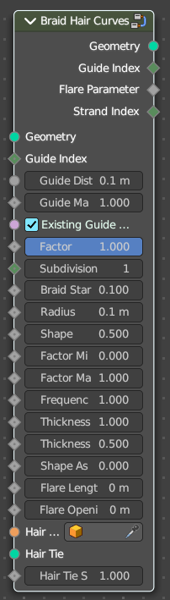
Braid Hair Curves
Deforms existing hair curves into braids.

Input

Geometry
The input geometry.

Guide Index
Index map input. This input has priority.

Guide Distance
Minimum distance between two guides for new guide map.

Guide Mask
Mash for which curve are eligible to be selected as guides.

Existing Guide Map
Use the existing guide map attribute if available

Factor
Factor to blend overall effect.

Subdivision
Subdivision level applied before deformation.

Braid Start
Where to start to blend deformation in percent from the root.

Radius
Overall radius of the braids.

Shape
Shape of the braid radius along each curve.

Factor Min
Minimum radius of the braid.

Factor Max
Maximum radius of the braid.

Frequency
Frequency factor of the braids.

Thickness
Thickness of the braids.

Thickness Shape
Shape adjsutment of the strand thickness for the braids.

Shape Assymetry
Asymetry of the shape adjustment of the strand thickness.

Flare Length
Length of the flare at the end of the braid.

Flare Opening
Opening radius of the flare at the tip of the braid.

Hair Tie Object
Object used for the hair tie instance.

Hair Tie
Geometry used for the hair tie instance. This has priority.

Hair Tie Scale
Scale of the hair tie instance.

Output

Geometry
The output geometry.

Guide Index
The guide index map that was used for the operation.

Flare Parameter
Parameter between 0 and 1 along the flare.

Strand Index
Index of the strand within a braid that each curve belongs to.

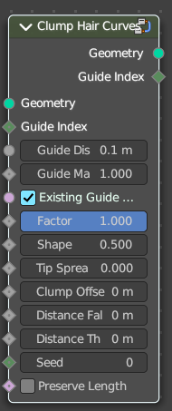
Clump Hair Curves
Clumps together existing hair curves.

Input

Geometry
The input geometry.

Guide Index
Index map input. This input has priority.

Guide Distance
Minimum distance between two guides for new guide map.

Guide Mask
Mash for which curve are eligible to be selected as guides.

Existing Guide Map
Use the existing guide map attribute if available.

Factor
Factor to blend overall effect.

Shape
Shape of the influence along curves. 0 means constant. 0.5 means linear.

Tip Spread
Distance of random sread at the curve tips

Clump Offset
Offset of clump in a random direction.

Distance Falloff
Falloff distance for the clumping effect. 0 means no falloff.

Distance Threshold
Distance threshold for the clumping effect. 0 means no falloff.

Preserve Length
Preserve the length of each curve during deformation.

Output

Geometry
The output geometry.

Guide Index
The guide index map that was used for the operation.

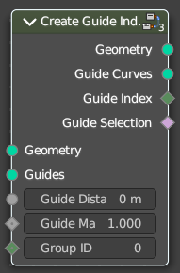
Create Guide Index Map
Creates an attribute that maps each curve to its nearest guide via index.

Input

Geometry
The input geometry.

Guides
Index map input. This input has priority.

Guide Distance
Minimum distance between two guides for new guide map.

Guide Mask
Mash for which curve are eligible to be selected as guides.

Group ID
The id that is used to group curves togethert for guide map creation.

Output

Geometry
The output geometry.

Guide Curves
The output guides

Guide Index
The guide index map that was used for the operation.

Guide Selection
The output guide selection.

Curl Hair Curves
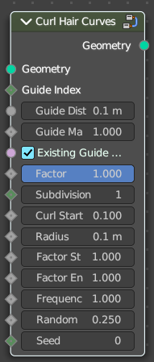
Deform existing hair curves into curls.

Input

Geometry
The input geometry.

Guide Index
Index map input. This input has priority.

Guide Distance
Minimum distance between two guides for new guide map.

Guide Mask
Mash for which curve are eligible to be selected as guides.

Existing Guide Map
Use the existing guide map attribute if available.

Factor
Factor to blend overall effect.

Subdivision
Subdivision level applied before deformation.

Curl start

Radius

Factor Start
Form where to blend deformation in percent, starting from the root.

Factor End
Factor for the radius at the curl end.

Frequency
Frequency factor of the curls.

Random Offset
Amount of random offset per curve.

Seed
Random seed for the operation.

Output

Geometry
The output geometry.

